FIT FLEX

**Introduction**

* + Project Title: Fit Flex
  + Project ID: SWTID1741254147153918
  + Team Leader: RAJ SHARMA D
  + Team Member: HARISH B [13 MAY 2005]
  + Team Member: YUVARAJ S
  + Team Member: SURENDAR P
  + Team Member: DEVA BALAJI U

**Project Overview**

**Purpose:**

Fitness programs designed to be versatile, allowing participants to adjust the intensity or type of exercises based on their personal fitness level, time constraints, or specific goals. These programs may include a mix of cardio, strength, flexibility, and endurance training.

**Features:**

* Customizable Workouts
* Variety of Exercise Types
* Accessibility
* Progress Tracking
* Time-Efficient
* Support for Home Workouts

**Architecture**

**Component Structure:**

* + - App.js - Root Component, Handles Routing
    - Exercises.js - Displays List of Available Exercises
    - *WorkoutPlan.js - Manages User-Created Workout Plans*
    - *Favorites.js - Handles Favorited Exercises*
    - SearchBar.js - Implements Search Functionality

**State Management:**

* + - Utilizes React's useState and useEffect hooks for managing workout routines, user progress, and fitness goals locally.
    - Data such as exercise plans, nutrition details, and progress tracking is fetched and managed using axios.
    - useContext is implemented for global state management, allowing seamless sharing of user preferences, workout schedules, and performance data across components (optional for future expansion).

**Routing:**

* Utilizes react-router-dom for navigation.

**Routes include:**

* + / - Home (Dashboard with workout summaries and fitness tips)
  + /workouts - Workout Plans and Exercises
  + /progress - User Progress Tracking
  + /favorites - Saved Fitness Routines or Favorite Exercises

**Setup Instructions**

**Prerequistes:**

* + - * Install [Node.js](https://nodejs.org/en/download/)
      * Install Git for version control ([Git Download](https://git-scm.com/downloads))
      * IDE: [VS Code](https://code.visualstudio.com/download)

**Installation:**

* git clone [repository_url]
* cd fit flex
* npm install

**Start the application:**

* npm run dev
* json-server --watch ./db/db.json
* # Start JSON server for backend simulation

**Folder Structure**

**Fit Flex**

│── src/

│ ├── components/ # Reusable UI components

│ │ ├── Navbar.js/ # Navigation bar for routing

│ │ ├── WorkoutCard.js/ # Workout details display

│ │ ├── Button.js/ # Custom button component

│ │ ├── Loader.js/ # Loading spinner for async data

│ │ └── ProgressBar.js/ # Fitness progress tracker

│── git ignore/ # Files to ignore in version control

│── package .js on/ # Dependencies and scripts

│── README.md/ # Project documentation

**Running the Application**

* **Frontend:**

npm run dev

**Component Documentation**

**Key Components:**

* + - * **Workouts.js:** Displays a list of workout routines with search functionality.
      * **Plans.js:** Allows users to create, add, or remove exercises from personalized workout plans.
      * **Favorites.js:** Manages favorite workout routines or exercises for quick access

**Reusable Components:**

* **SearchBar.js:** Search input for filtering workout routines or exercises.
* **WorkoutPlayer.js:** Custom guided workout playback component (e.g., video or audio instructions for exercises).

**State Management**

* **Global State:** Not yet implemented (potentially using Context API for managing user data, workout preferences, and nutrition plans).
* **Local State**: Managed with use State for tracking workout progress, selected exercises, and fetching data via axios

**User Interface**

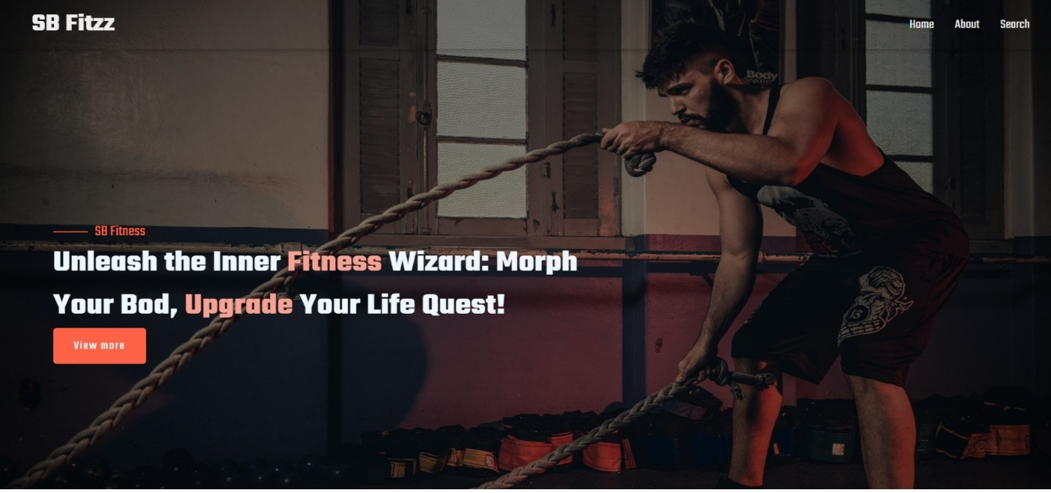



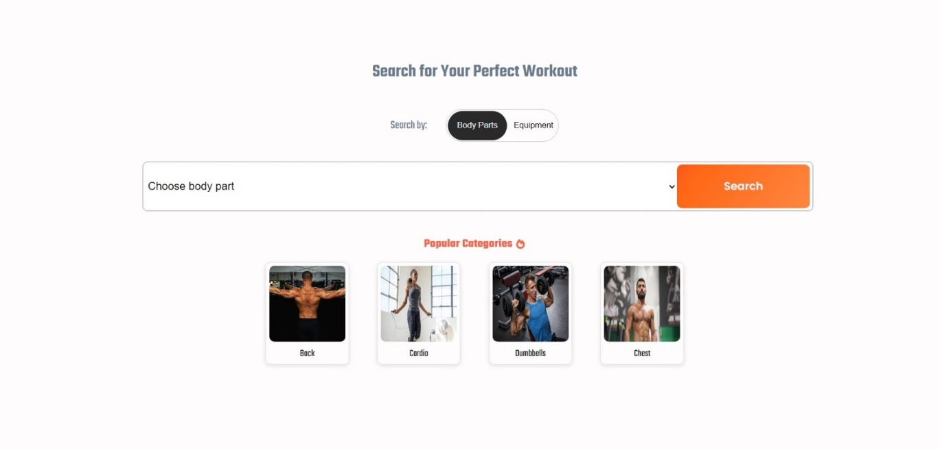

**Styling**

**CSS Frameworks/Libraries:**

* + - Bootstrap/Tailwind CSS
    - Custom CSS for additional styling

**Testing**

**Testing Strategy:**

* Unit tests with Jest & React Testing Library (future enhancement)

**Code Coverage:**

* No test coverage tool implemented yet

**Demo**

<https://drive.google.com/file/d/1tqY8mBg7Js8K3VCJvYELWf7UujlyotIR/view?usp=drivesdk>

**Known Issues**

• Some workout videos or exercise content may not load in certain browsers due to CORS issues   
• Limited offline access to workout plans and fitness resources

**Future Enhancements**

• Implement user authentication for personalized fitness tracking  
• Improve UI with animations for workout progress, achievements, and transitions  
• Integrate a real fitness API for exercise routines, workout videos, or health data tracking